**Instructions 91896 (Advanced programming) L2 6 credits**

Submission :

Name : Daksh P.V. Makwana

Links:

Moonday.com :<https://dakshs.monday.com/boards/1518038569>

**PLANNING**

* **What am I making?**

**->**  Im making a Multi choice Quiz about Cricket and basketball

* **What i'm using to plan my work ?**

**->** I'm using Python to make my quiz. And I'm using Google docs / Google slides / Monday.com to Plan out my quiz.

**Project Management: Setup & Applied**

Record evidence that you have set up project management tools to manage the development of your outcome.

Setup : In order to make my project a high level i had to use a project management to make my planning better so i used Monday.com to use as my project management as i feel like it is a much easier software to use than other as it is very simple and saves the data automatically.

Here is the link for my project management software I used . : [https://dakshs.monday.com/create_board_from_template](https://dakshs.monday.com/boards/1518038569)

I was confused as to which project management tool to use between monday.com and trello as most of my friends were using trello but I decided to use monday.com as I felt it was easier to use in my opinion.

I felt that monday.com was very good even though it is mostly meant to be used for group projects it worked properly for me using it individual some things i love about monday.com is that u can add tasks very easily and change the status having (Done, Working on it, Stuck) which was a very helpful method i used throughout this programme.

Record evidence that you have chosen project management techniques to manage the development of your outcome.

**->**

One of the things I used to manage my outcome on monday.com was that everytime i had a problem on the code I would change its status on stuck and put a reminder To tell me to get help from the teachers .

Another thing I could use to manage my outcome in Monday.com was to simply just add the teacher to the task which I was stuck at and ask her for some feedback to help me fix the code by just adding the teachers email next to the task.

There were also other things such as sharing and scheduling which I could use to manage my project to help make my quiz better. Sharing would allow me to share my plan with the teacher and ask her if I need any changes in my plan.

Record evidence that you have set up/ chosen version control tools/techniques to manage the development of your outcome.

**->** 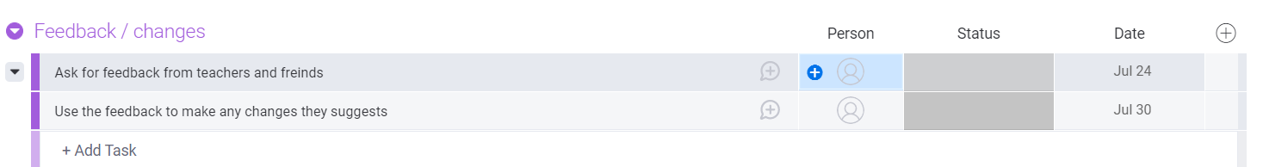

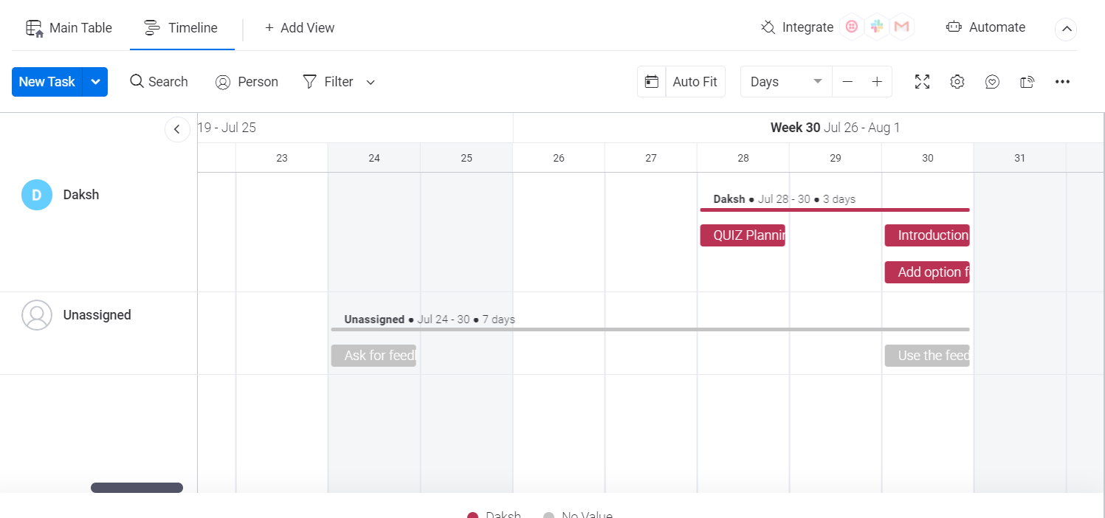

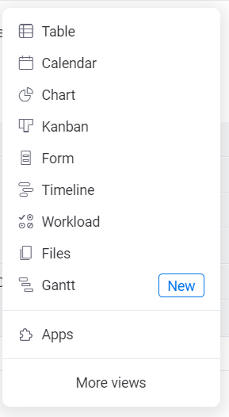

Explain why you believe that these tools and techniques are appropriate for the development of your outcome.

**->**

These tools and techniques are appropriate for the development of my outcome because these tools are very useful as i could set reminders put a timeline on my work to make the process of making my quiz nicely this can help me keep track of my progress another benefit of this is that it allows me to spread my work evenly in a given time.

Decomposing outcome

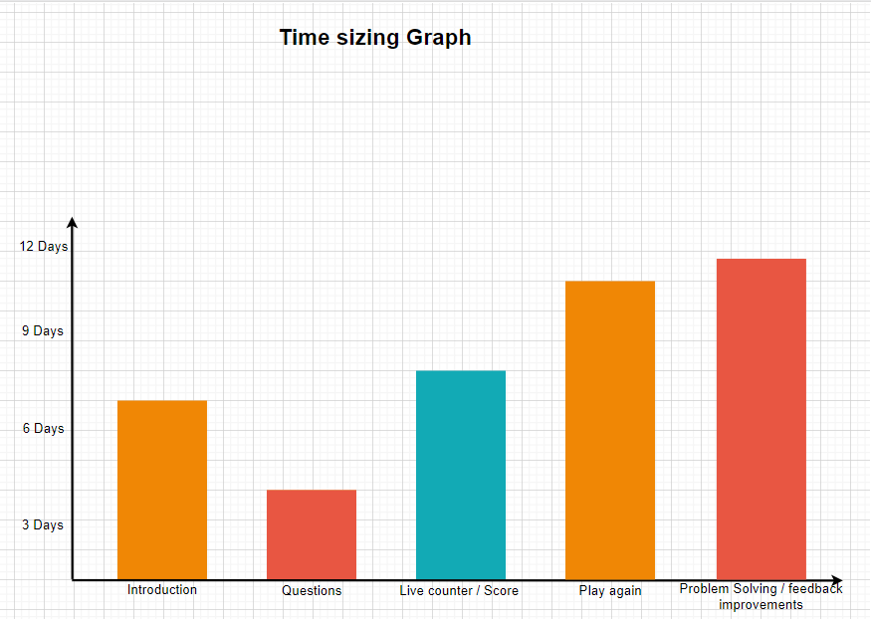

**For Decomposing my outcome i divided my work into 5 things 1st was Introduction, 2nd writing the Questions, 3rd adding lives counter / score / right and wrong answers, 4th i worked on doing the Play again, 5th problem fixing and adding from feedback**

**I Divided My Project Of Making A Cricket / Basketball Quiz In 5 Areas.**

* **Introduction**
* **Questions**
* **Live counter / Score / Correct and wrong answers!**
* **Play Again**
* **Problem fixing**

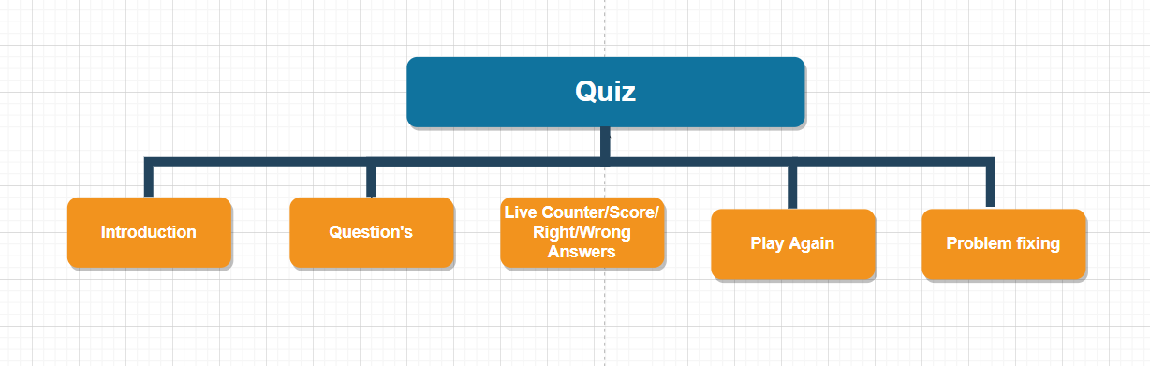

**In Introduction i had to write the code of Introducing my program asking users name and gender and asking if they would like a Cricket or Basketball quiz.**

**#Introduction!**

Trialing

Record evidence that you have trialled components. Show that you gathered information to inform your decision making.

Record evidence that you have trialled multiple components and have selected those most suitable.

Record evidence that you have used information from trialling appropriately to improve the functionality of the outcome.

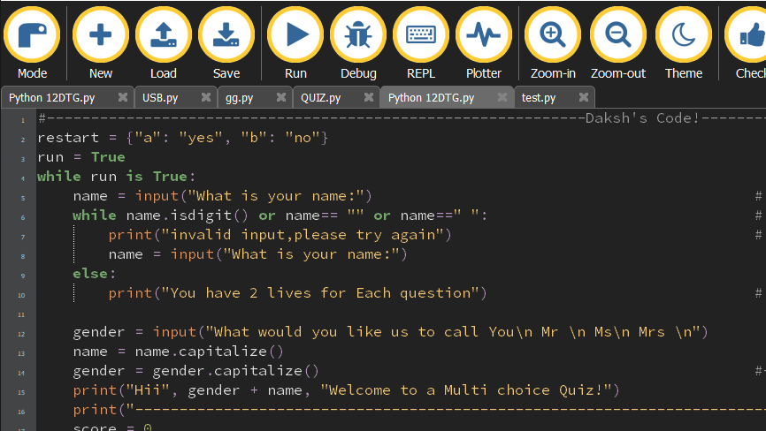

* Planning out Question!

In this I made up / Searched the questions i wanted to write in my Quiz and wrote it down in the Code.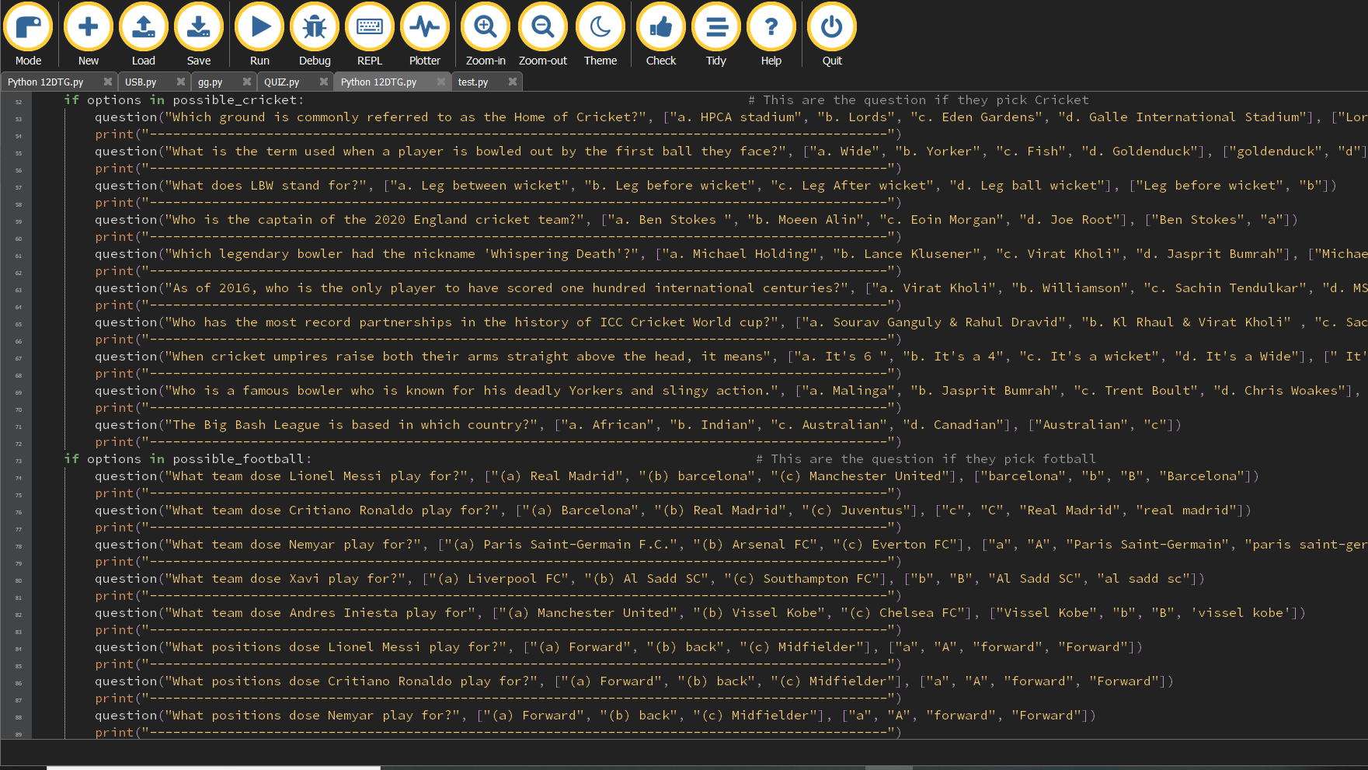

Adding Live Counter / Scores / Correct and Wrong Answers!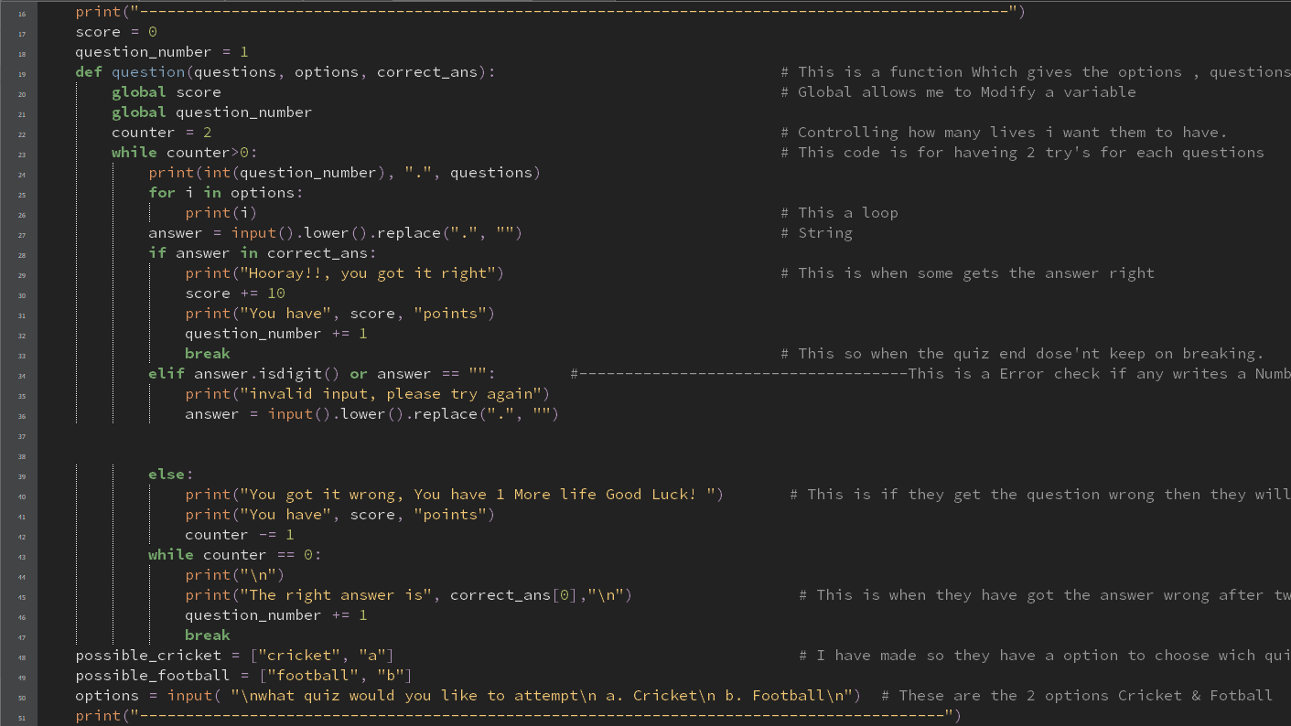

* Play Again

I had to add play again as it was a requirement.

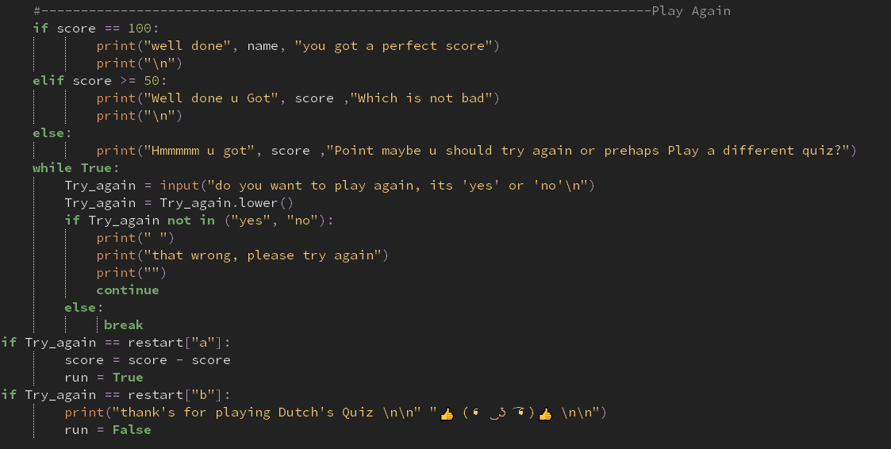

I used Mu for my progrramin software instead of pycharm as I had been using pycharm before and I wanted to try something new as I used Mu Editor for the first time. I felt like it was very simple to use. Mu also had a validation checker which was very handy figuring out the problems in my quiz

Code in Pycharm

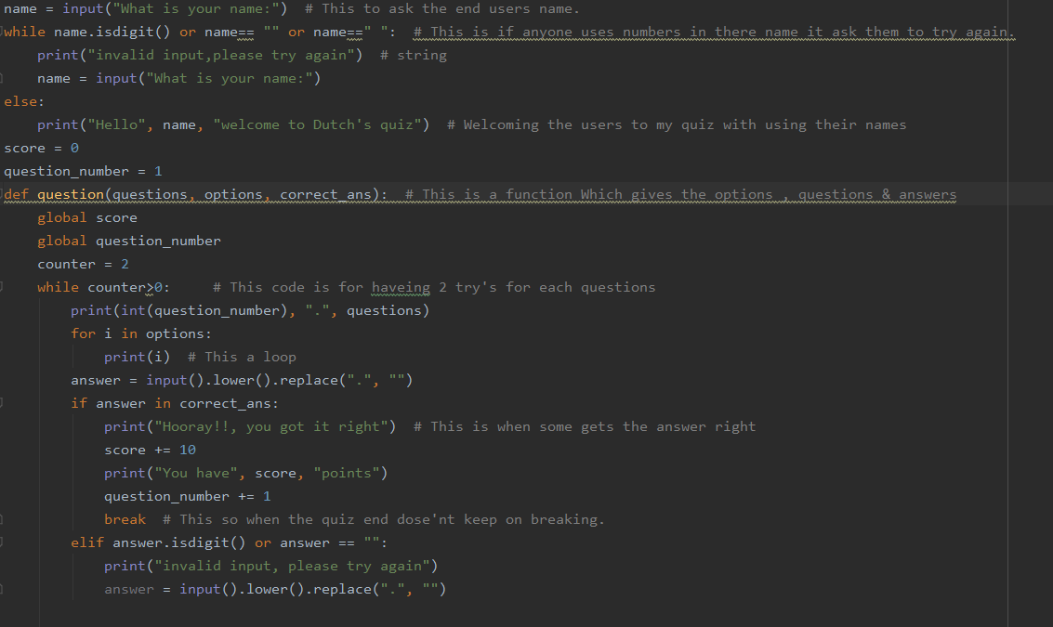

Vs Code in Mu

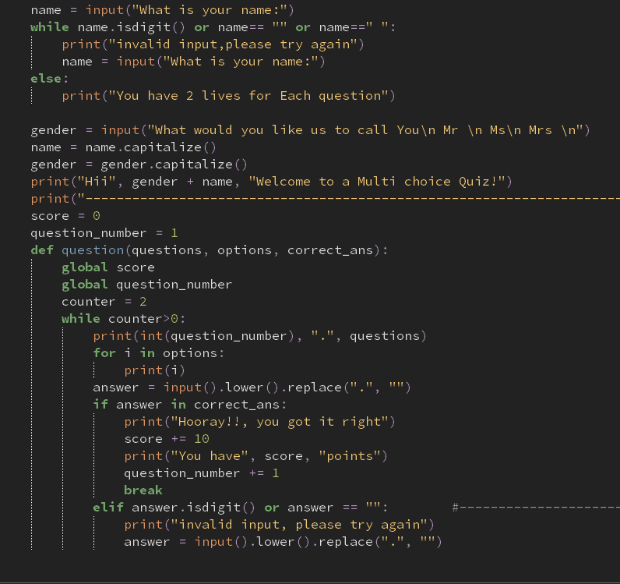

I feel that mu is much more bright and easier to look at than pycharm.

#2

My code without vs with playagin

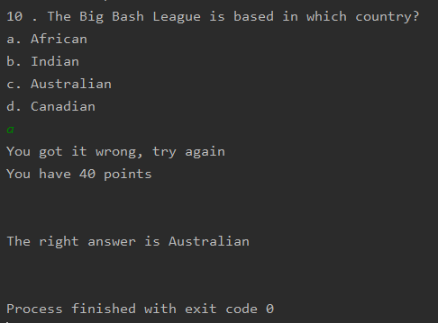

Vs with Play again

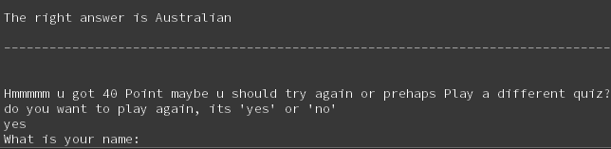

I think that this made my code much better, making it easier to use the quiz.

Stakeholder

#1

| Name : Zeel  Feedback :  I think that this quiz was very good. It was a very nice quiz. I liked how there were 2 options for me to chase which quiz I would like to try. Overall this quiz is very good and maybe you should try to add some feature that tells you how well you did. | Reflection:  Looking through Zeel’s feedback I think that i did a good job of making this quiz but i will have to add a feature that says how well the user played showing their score and maybe asking them to play again. |
| --- | --- |



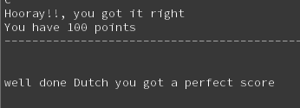

#2

| Name: Prachi  Feedback: I really liked how the quiz was made with all the questions and the feature of giving play again and I liked how there were 2 options to which quiz i would like to play. | Reflection:  I think that these comments were very nice and that I did not need to add anything more from this feedback. |
| --- | --- |

Project management: Applied

STill Working on

Record evidence that you have used your project management tools to manage the development of your outcome.

Record evidence that you have used your project management techniques to manage the development of your outcome.

Record evidence that you have used version control tools to manage the development of your outcome.

This is my board before starting

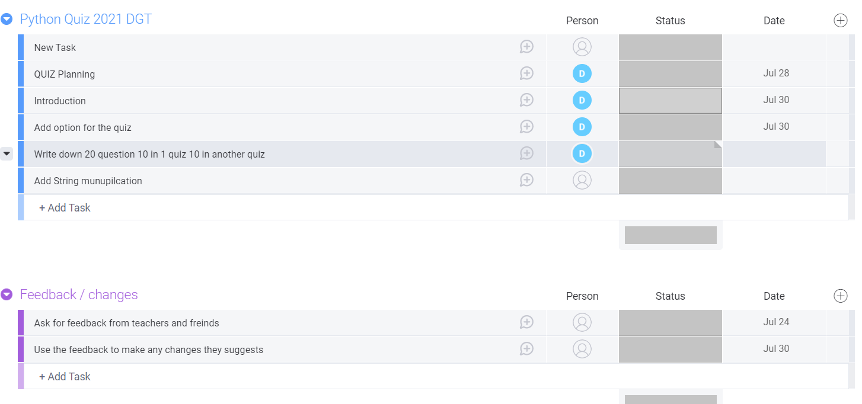

This is my Board at the end.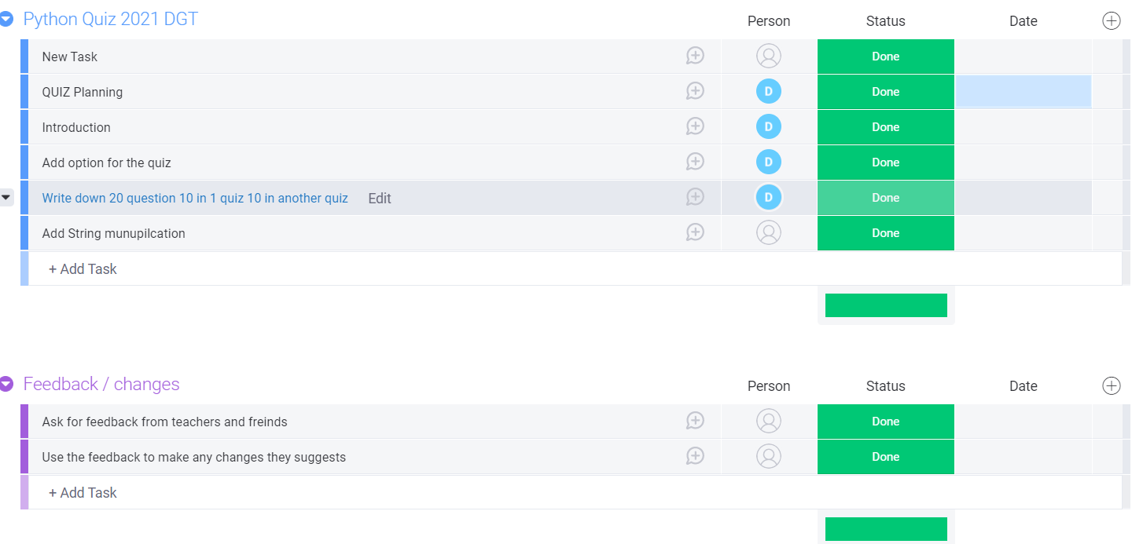

Techniques I used throughout my project were the celdender, timeline and charts to help with my project were useful techniques that I used to keep an eye out on my progress made me stay on track to finish the project in time.

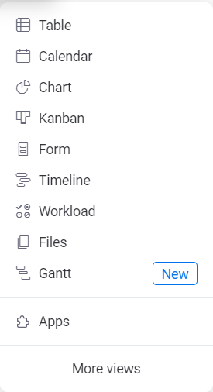

Version Control



I split my code into 4 version Version 1 were i do introduction / Version 2 were i add live counter and score /version 3 were i had add all my questions and Version 4 where i add play again feature i decided to split my code in 4 version as i thought if i ever had any problem in code or if i mess up my code i could always just go back and do the code again this way i can get back on track.

Version 1

In version 1 I had programmed the code to introduce the quiz, how it works and ask the users name and if they would like to be called (Mr, Ms, Mrs) to use string manipulation which was one of the requirements of the code.

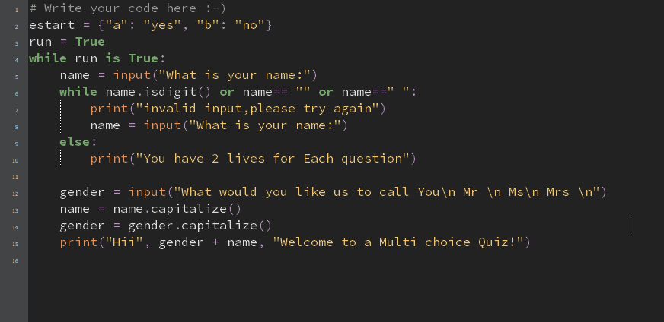Version 2

Version 2 I had added the lives conter giving the user 2 lives per question and added a counter besides that to keep an eye out on their score.

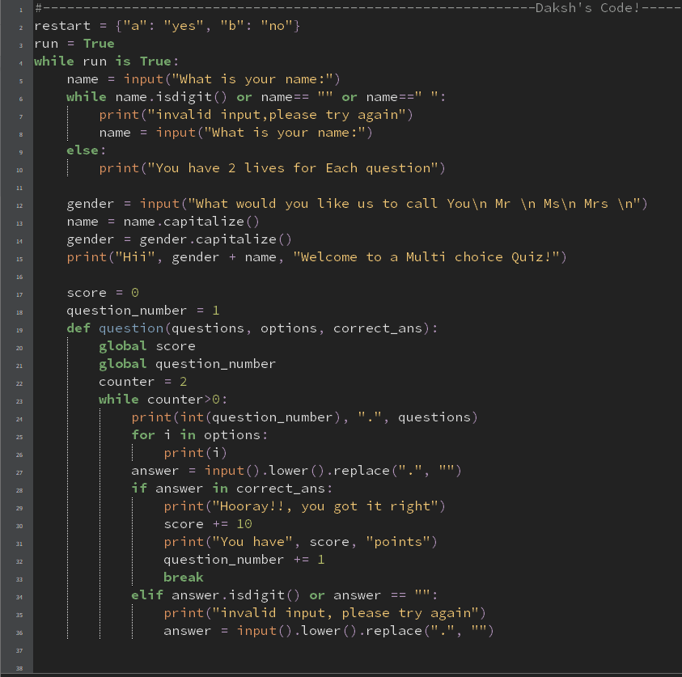

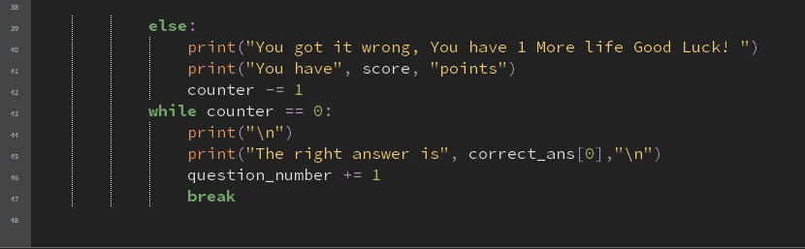

Version 3

Version 3 I added all my questions and Answers to the Quiz for both cricket and football quizzes.

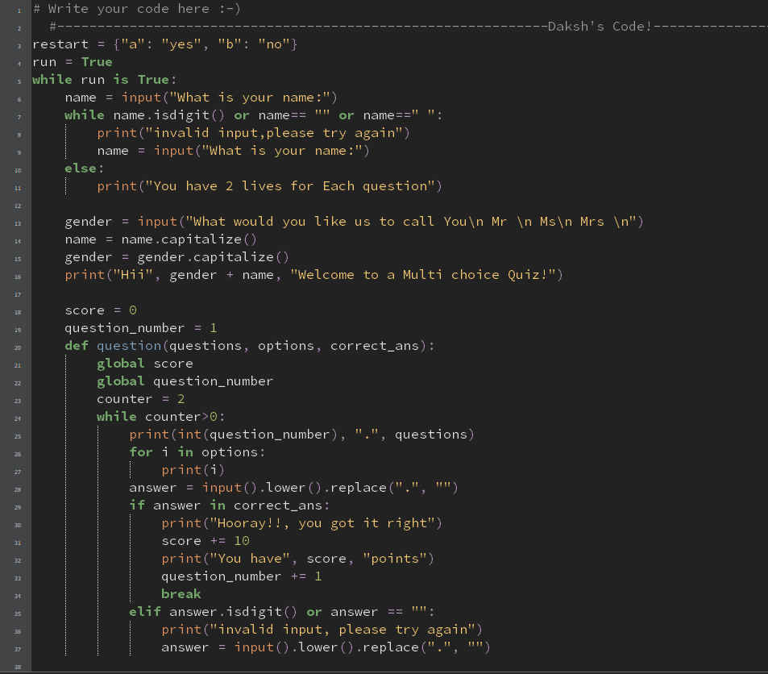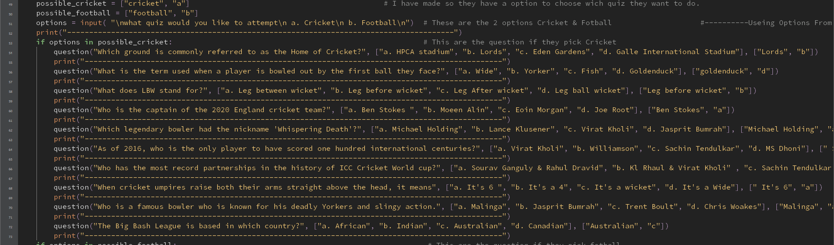

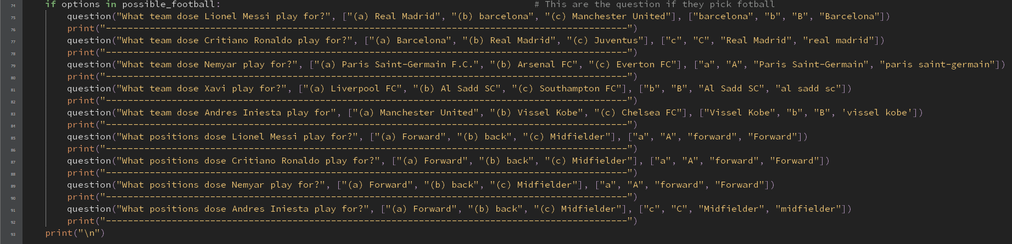

Version 4

In version 4 I had added Play again! Which allowed the user to have an option to play the quiz again if they wanted to try out a different quiz.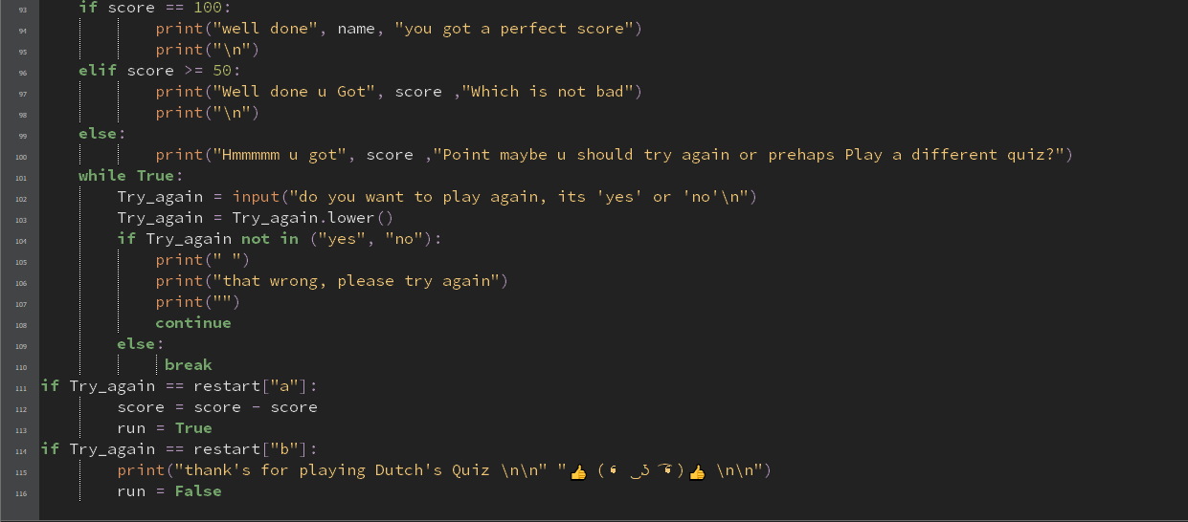

Testing outcome

Record evidence that you have tested your outcome.

Explain how the testing made sure your outcome functions as intended to meet its purpose and requirements.

Record evidence that you have used information from testing appropriately to improve the functionality of the outcome.

My code without lines

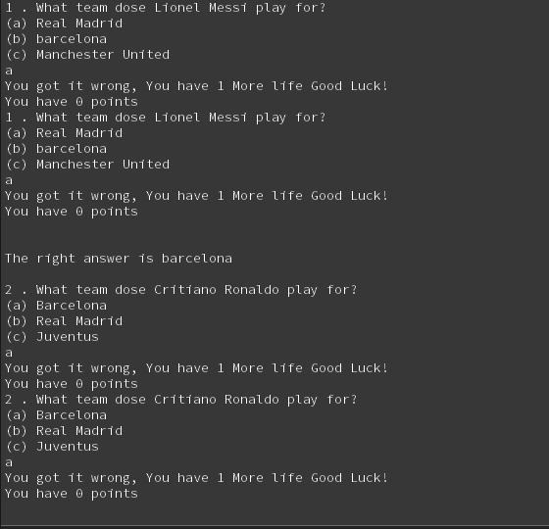

Vs With lines 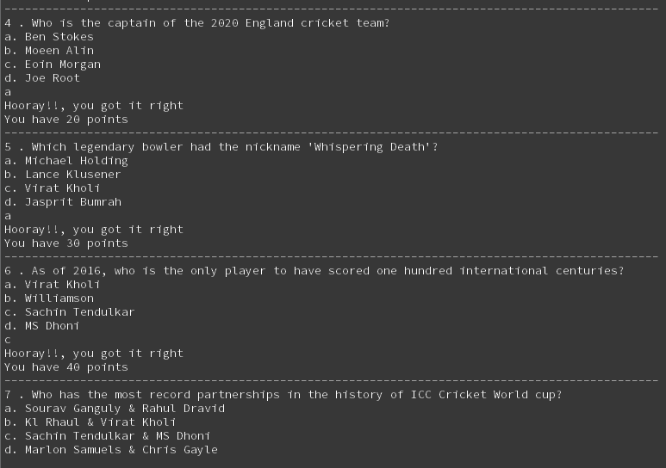

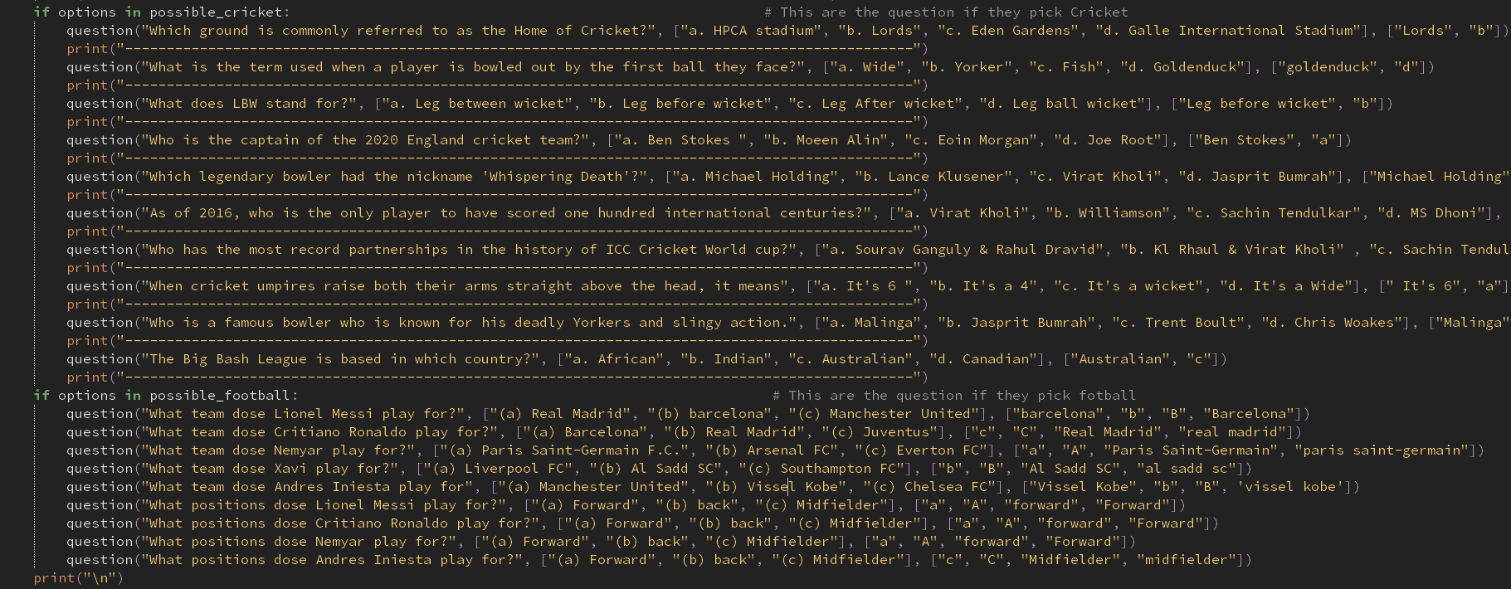

Testing table

Input?

Entered numbers when asked for Name.,

What to expect?

Show an error and says try again.

What actually happened?

Showed an error and tried again.

Fixes?

Nothing needed.

#2

Input

Choice a wrong option instead of a, b ,c , d or wrong spelling

What to Expect?

Give a Try again To write the answer again

What actually happened ?

Showed as an wrong answer

Fixes?

Had to change my code to add an error handler.

STILL WORKING ON

Debugging

Bug 1

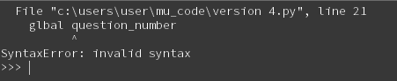

Fixed

Bug was because of my spelling mistakes which happened a lot while building this code.

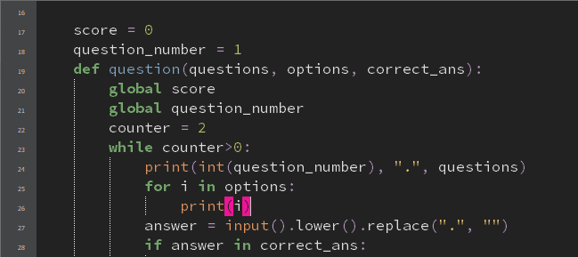

Bug 2

In bug 2 the right answer just kept on repeating.

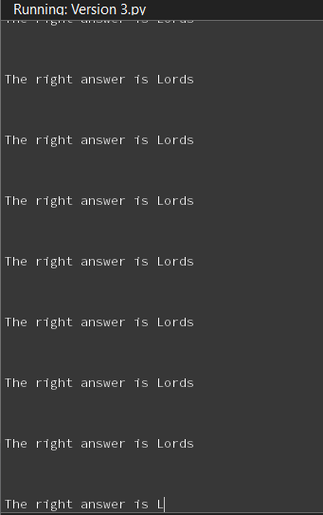

Fixed

By adding Break this would stop the right answer from repping over and over.

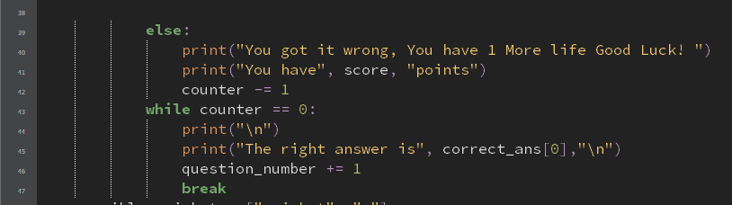

Bug 3

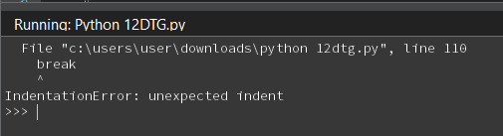

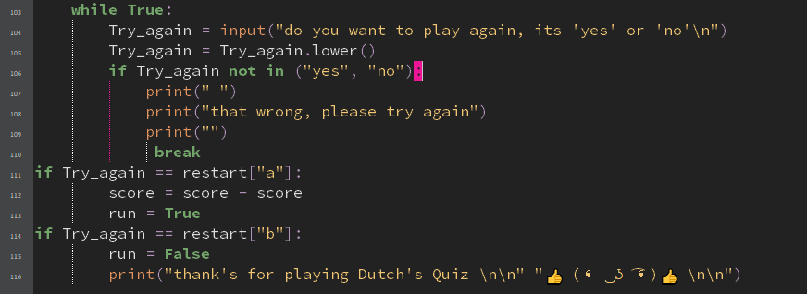  
Fixed

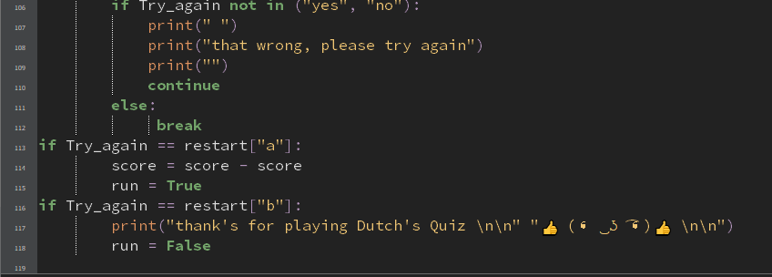

PEP8

In My pep8 validation my code had many errors for lines too long as I added many comments besides the code which gave me many lines to long eros but besides that my code had no other errors . If I had given these comments properly I would have had a clear validation. I had many other errors in between but I fixed them all. This taught me to write my comments in a proper manner as if I could have gotten a lower grade for my code.

Usability testing

Stakeholder

| Name : Harsh   * It's a very good quiz. I enjoyed playing it. * I liked that the questions were not that easy or too hard to try to make it equal. * I think that the quiz looked a bit scrambled and wasn't very easy to read, everything looked clustered. Maybe try to give more space between questions and answers. * Overall this quiz was very fun and good. |
| --- |

Reflections : After going through Harsh feedback, I decided to make the quiz look much nicer and easier to read by putting spaces and --- lines in the quiz to make it look more clearer.

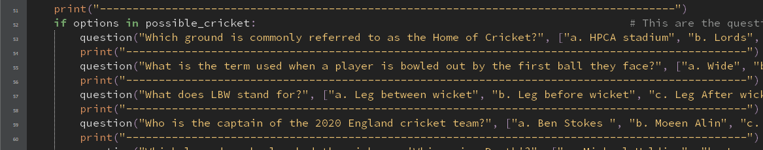

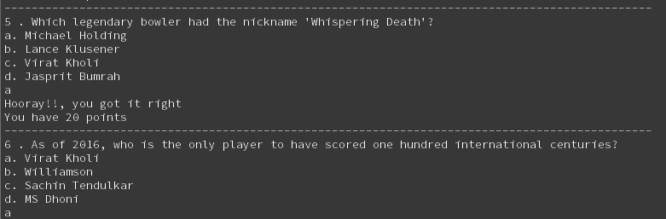

Evacuating Against Requirements

I wanted my quiz to be a very good and a fun quiz which users could enjoy for this i had to get a lot of feedback from my friends and mom which helped me make this a very nice quiz i also made the quiz with 2 option Cricket and basketball instead of just 1 quiz which now users can try out both quiz maybe if they are good at basketball they would like to play the basketball quiz, or if they wanted to test their knowledge in how much they know about cricket. Another requirement that I decided to add was play again as my quiz has 2 options cricket and basketball. I thought it would be better if I added a play again feature so the user could try out the other quiz as well.

Evacuation against relevant implications

In order to make my quiz the best i thought about many different implication such as copyright/ legal because i didn't want anything that i use as copy write for example my questions what if a user has already done the same questions before in some other quiz so i decide to think about relevant implications for my quiz even tho it does not have many implications needed i still thought of future proofing / usability which would help upgrade my code in future if i ever need it.

Final Testing

<https://drive.google.com/file/d/1iFB2bs8HaPySUEEIi084AA8Z_1MJoWP7/view?usp=sharing>

Implications

**Functionality**

* **In my quizI have made sure that my quiz is safe and functional by getting some feedback from my friends and family from which they can notify me if there are any mistakes in the quiz or if I should do something additional which can benefit my quiz. The importance of functions is that it can repetitively perform its task and it is also safe, easy to use and it has durability to sustain its function. Benefits of Functional Testing It ensures that all the requirements should be met. It ensures the proper working of all the functionalities of my quiz and that it is perfect to use.**

**Privacy**

* **I have made sure to give my end users full privacy excpt for asking their name and their gender to welcome them to my quiz. Maintaining privacy and protecting personal information of the Users is important for my quiz as it allows my users to enjoy the quiz without any stress of losing their information to others . Privacy management should go beyond mere regulatory requirements, since it not only impacts an organization's reputation**

**Copyright/Legal**

* **I had made sure not to copyright anything by using my own questions and my own design of the quiz as it would not be legal copyright is a good way to make my quiz show that it has been entirely made by me so all the credit goes to me**

**Social/Culture**

* **culture provides important social and economic benefits. I have made a quiz which does not at all include any sort of photo or text which can be offensive to any one’s culture i have not used any other language or wrote anything about anyone’s belief because it could potentially be offensive towards my end users**

Evaluation

I chose Monday.com as my project management tool as I feel that it was very simple and had many effective methods which helped me think out making the code as I could just add reminders or add the teacher next to the task which I was stuck at for her to help me how I could fix it.

I checked my code every time i add a function or wrote some come to make sure that if i had any errors in my code which could ruin the part of my code and i if i did i would try to fix the error straight away instead of waiting as i feel like i would forget what the errors was or what i added. I had many errors throughout my code which made me feel very stressed and frustrated but in the end it all worked out even though I only achieved a goal for my code. I'm still very proud of my code.

Overall I think that it was all planned out how i imagined, in the end i decided to add the feature play again which let the users have an option to play the quiz again or try out a different quiz which i think is one of the best feature that i added in the code which made my quiz feel bit professional.

I know that I could have done better than this but I was very distracted and that led me to only getting an achievement . I believe that I can do a much better job of making a quiz or a game using python from learning through this and if I could have done a better job of verifying through pep8 checker more often.